Published by | Editorial Office

HEWI
Marketing + Innovation

HEWI Heinrich Wilke GmbH
Postfach 1260
34442 Bad Arolsen
Germany
Phone: +49 5691 82-0
presse@hewi.de
www.hewi.com

Lisa Meyer-Floren
Phone: +49 5691 82-214
lmeyer-floren@hewi.de

Nicolo Martin
Phone: +49 5691 82-106
nmartin@hewi.de

Reproduction permitted, kindly provide sample copy

Dispenser systems
Manual or electronic
Well-thought-out down to the smallest detail: HEWI dispenser systems meet the highest standards in terms of design and functionality. The range includes manually operated versions as well as a selection of electronically operated touch-free dispensers. The wide choice of dispenser system materials offers plenty of scope in terms of design.
System 900
A new matching dispenser system is now available for the successful bathroom range System 900 in a choice of finishes: powder-coated in black, shades of grey and white, as well as stainless steel models. The dispensers are extremely robust and are therefore perfect for highly frequented sanitary spaces. A lock with a key offers protection against misuse. The majority of the dispensers is not only available in a manual but also in a Sensoric version. From soap and disinfectant to paper towel dispensers and waste bins, as well as hygiene combinations in various sizes, HEWI offers a matching functional range that is also meets the most discerning design standards.

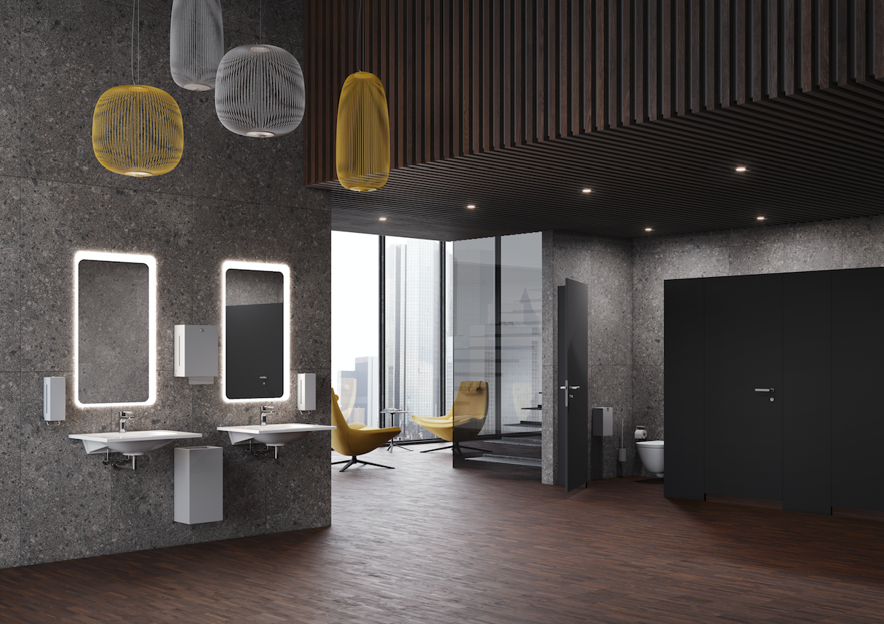
HEWI Dispenser System 900

HEWI | Public

Furnishing solutions for public and semi-public areas should always reflect the character of the premises with a representative design. The ambience, user well-being, cost-effectiveness and sustainabilit are additional important aspects to be considered during their planning and realisation. HEWI makes it possible to consistently meet these requirements.Carefully selected and crafted materials result in high-quality products that are able to withstand a high user frequency over many years.

