Published by | Editor

HEWI
Marketing + Innovation

HEWI Heinrich Wilke GmbH
Postfach 1260
D-34442 Bad Arolsen
Phone: +49 5691 82-0

presse@hewi.de
www.hewi.com

Reprint free - specimen copy requested

Freestanding Accessories
Upright Designs for Washbasin and WC
With flexibly usable upright products for the washbasin and WC HEWI creates even more design options. As freestanding accessories they can be used wherever they are needed.
Due to the reduced and universal system design they can be combined with different HEWI sanitary system. The holders have a high-quality chrome finish; the inserts are made of satin-finish glass. A synthetic material insert positions the glass inserts in the holder stably and securely and ensures a high degree of stability.

Design: HEWI

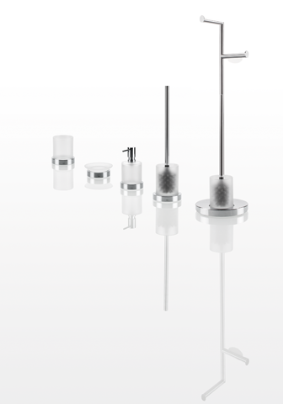

Freestanding accessories

Further information is available from:

HEWI Heinrich Wilke GmbH
Postfach 12 60
D-34442 Bad Arolsen
Phone +49 5691 82-0
Email: info@hewi.de
Internet: www.hewi.com

