Published by | Editor

HEWI
Marketing + Innovation

HEWI Heinrich Wilke GmbH
Postfach 1260
D-34442 Bad Arolsen
Phone: +49 5691 82-0
presse@hewi.de
www.hewi.com

Reprint free - specimen copy requested

Range 805
Functional Sanitary Accessories
The reduced design of Range 805 enables clear structuring of a room. Down to the smallest detail, this Range shows that good design and intelligent functions can form an integrated whole. The functional area of the products is contrasted in colour with high-quality polyamide. By using polyamide the controls are pleasant to grip. The colouring (optionally pure white, anthracite grey or black) makes them clearly stand out in rich contrast and they are therefore easily recognised.
Universal Design takes into account the needs of all users. The products were developed on the basis of this philosophy. The Range not only includes classic sanitary accessories but also products with a slightly supporting effect, through to those with complex, accessibility functions for use in the standardised public segment.

Design: HEWI
Awards: iF product design award 2008,
red dot award: product design – honourable mention 2008

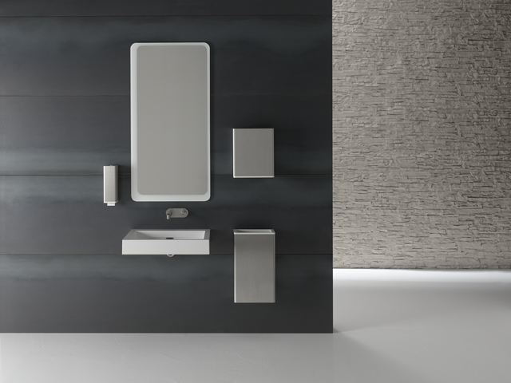

Range 805

Further information is available from:

HEWI Heinrich Wilke GmbH
Postfach 12 60
D-34442 Bad Arolsen
Phone +49 5691 82-0
Email: info@hewi.de
Internet: www.hewi.com

